Assessment Schedule – 2015

Calculus: Apply the algebra of complex numbers in solving problems (91577)

Evidence
Q1 | Expected Coverage | Achievement  u | Merit  r | Excellence  t
(a) | 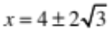 | Correct solution.
(b) | 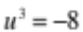 clearly marked on Argand diagram. | Correct solution.
(c) | 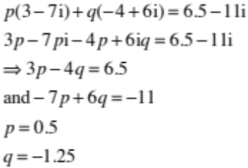 | Correct second line. | Correct solution.
(d) | 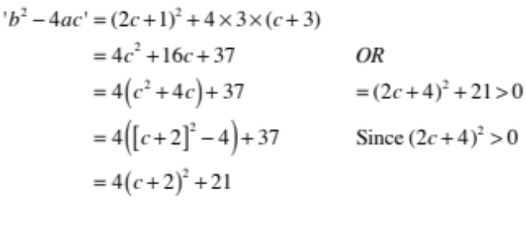  ≥ 0  ≥ 0  Which is always positive, as 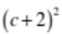is always positive. | Correct second line. | Correct solution.

(e) | 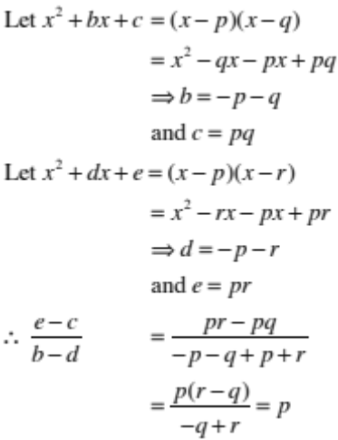 | The two ‘let’ lines. | Successfully equating coefficients. | Correct proof.
 | OR  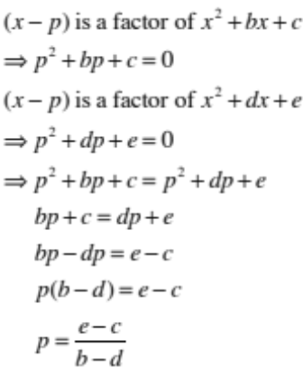 | EITHER  p² + bp + c = 0  OR  p² + dp + e = 0 | Equating the two equations in the ACH column. | Correct proof.

NØ | N1 | N2 | A3 | A4 | M5 | M6 | E7 | E8
No response; no relevant evidence. | 1 partial solution. | 1u | 2u | 3u | 1r | 2r | 1t with 1 minor error. | 1 t

Q2 | Expected Coverage | Achievement  u | Merit  r | Excellence  t
(a) | –23 | Correct solution.
(b) | 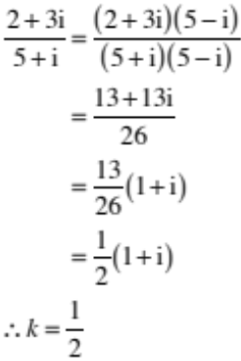 | Correct solution.
(c) | 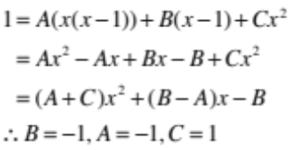 | Correct second line. | Correct solution.
(d) | 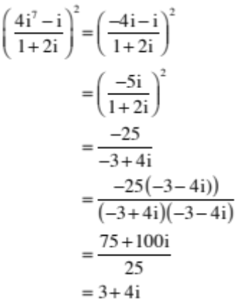 | Correct third line.  Or CRO | Correct solution.
(e) | 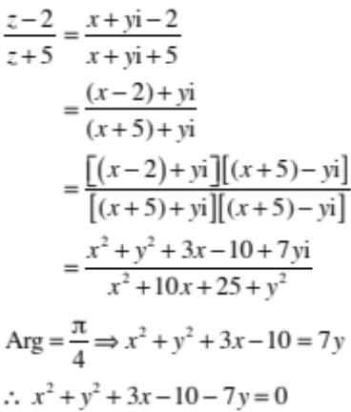 | Correct second line. | Correct ‘simplification’, 4th line.  Accept correct factorised denominator. | Correct solution.

NØ | N1 | N2 | A3 | A4 | M5 | M6 | E7 | E8
No response; no relevant evidence. | 1 partial solution. | 1u | 2u | 3u | 1r | 2r | 1t with 1 minor error. | 1 t

Q3 | Expected Coverage | Achievement  u | Merit  r | Excellence  t
(a) | 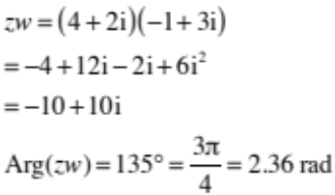 | Correct solution.
(b) | 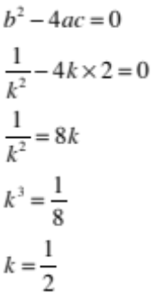 | Correct solution.
(c) | 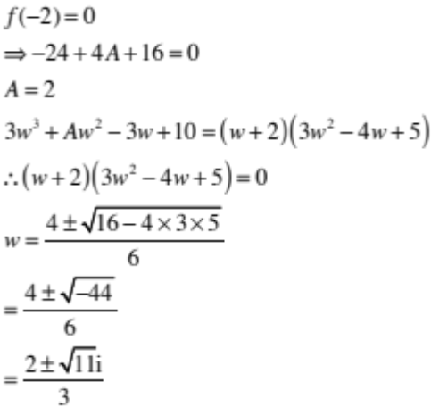  Or 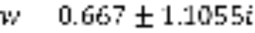 | Correct value of A found. | Correct solution.
(d) | 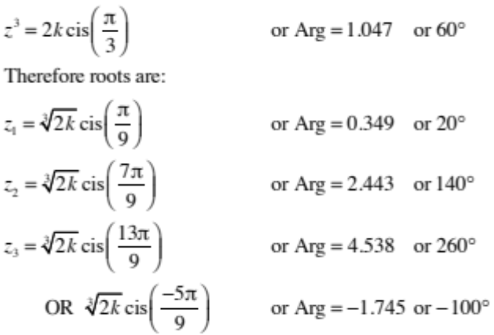 | One correct solution or 3 correct arguments. | Three correct solutions – allow alternative correct values.

(e)(i)  (ii) | 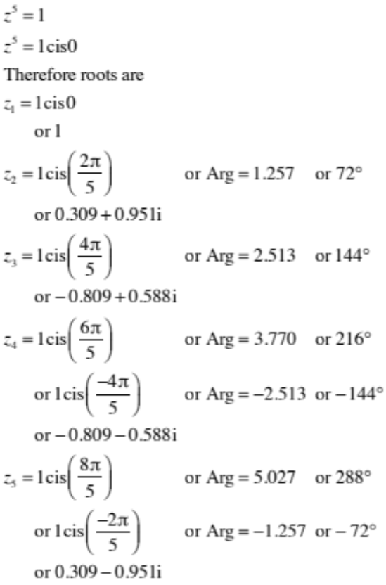  Let 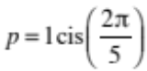 which is z₂ above or   Then  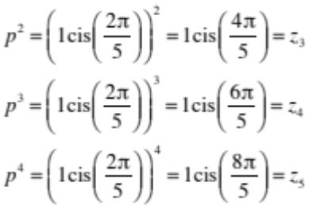  And 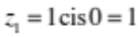  ∴ roots are 1, p, p², p³ and p⁴ |  | Correct values of  z₁ to z₅. | Correct solution.

NØ | N1 | N2 | A3 | A4 | M5 | M6 | E7 | E8
No response; no relevant evidence. | 1 partial solution. | 1u | 2u | 3u | 1r | 2r | 1t with 1 minor error. | 1 t

Cut Scores
Not Achieved | Achievement | Achievement with Merit | Achievement with Excellence
0 – 6 | 7 – 12 | 13 – 18 | 19 – 24

